

**LEARN HOW TO USE TINKERCAD**

**Design, program, and test electrical circuit virtually.**

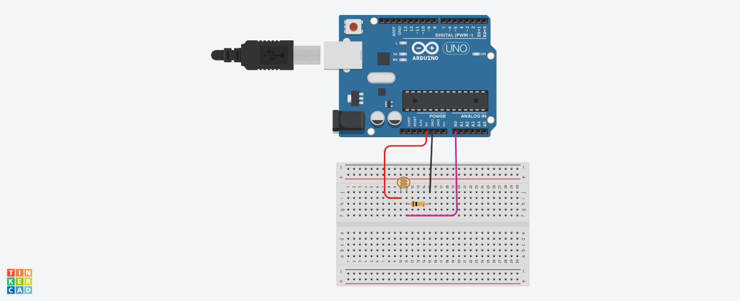

Contents

I. Introduction 2

II. Create a Tinkercad Account and Create a New Project 2

III. Create New Circuit project 3

IV. Building the Circuit 7

V. Programming with Arduino 12

# I. Introduction

Tinkercad is a free and easy-to-use application for 3D design, electronics, and coding.

From an idea to projects in minutes!

Autodesk's Tinkercad is one of the most popular classroom tools for creating simple designs from scratch and for quickly modifying existing designs. It is a free online 3D design program that you can use in your web browser without downloading any software. Tinkercad is extremely intuitive and easy to use and has built-in Lessons to help you learn the ropes, making it perfect for beginners both young and old.

No need to buy any physical components, sensors, Arduino boards or modules.

No destruction of any physical components if circuit is incorrect.

Make your presentation clean and professional.

# II. Create a Tinkercad Account and Create a New Project

Access to <https://www.tinkercad.com/>

Click **join now** and follow online instruction to create an account. Select **Create a personal account**.



# III. Create New Circuit project

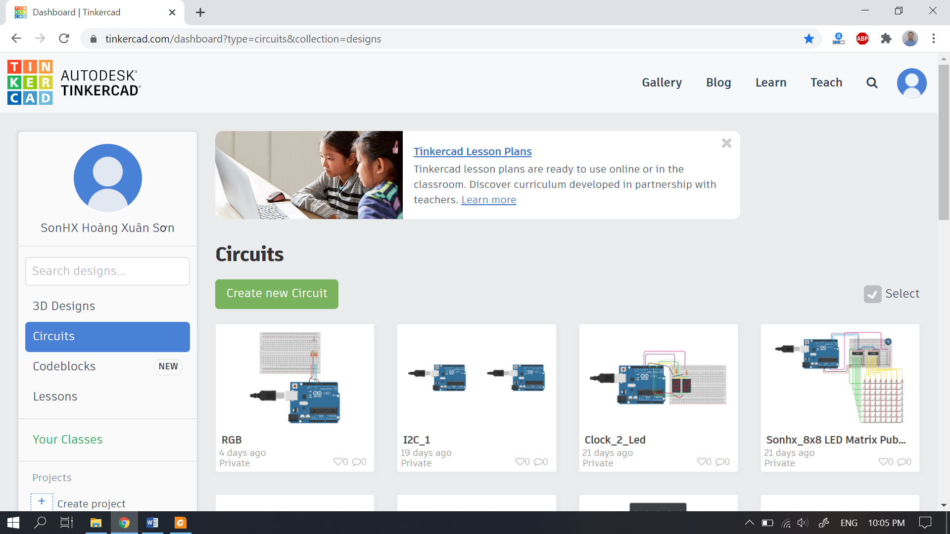

***3D Design:*** *Tinkercad is similar to a CAD software where you can design 3D models for 3d printing. The CAD software is based on constructive solid geometry (CSG), which allows users to create complex models by combining simpler objects together.*

***Circuits:*** *This option helps create a virtual circuit, program it, and test it in real time.*

***Codeblocks:*** *This new feature helps you create a block programming tree, where the 3D models are formed step by step following the tree instructions.*

***Lessons:*** *Tinkercad has feature where one can learn from lessons created by different users online and can access later with this option.*

***Create project:*** *This will create a directory where you can store all 3D models and circuit for one specific project.*

Select the **Circuits** option and **Create new Circuit**.

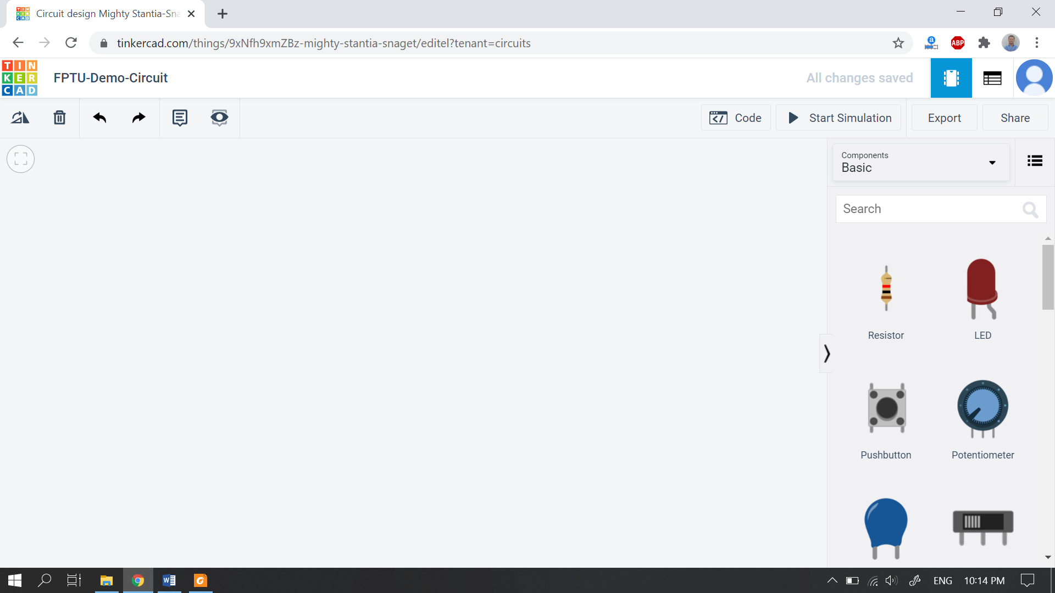

**2**

**1**

**3**

**4**

*1. This space is where we will place all the components. The components can be moved around, edited, and wired together.*

*2. This section holds all the components. Scroll down to access component types.*

*3. Use this tab to rotate, delete, undo or redo. It also helps users to create and name labels for components.*

*4. This option helps you program Arduino, use serial monitor, start real time simulation, export code, and share your projects.*

These are the components available in the basic option.

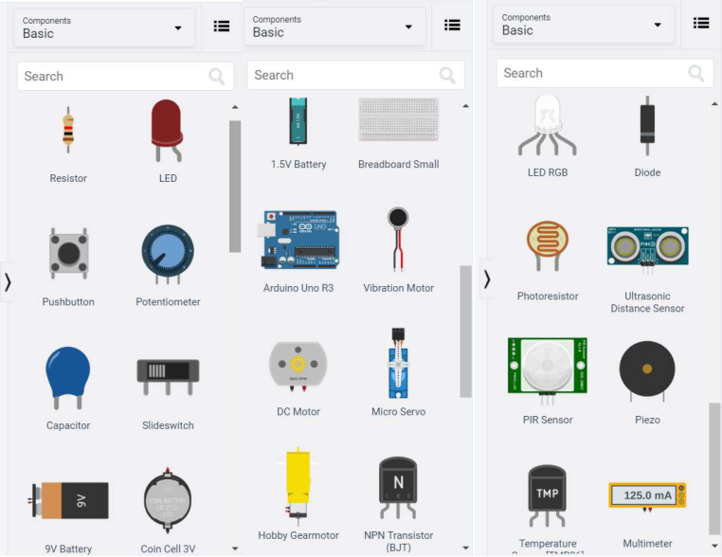

To get access to more components select **All** option.

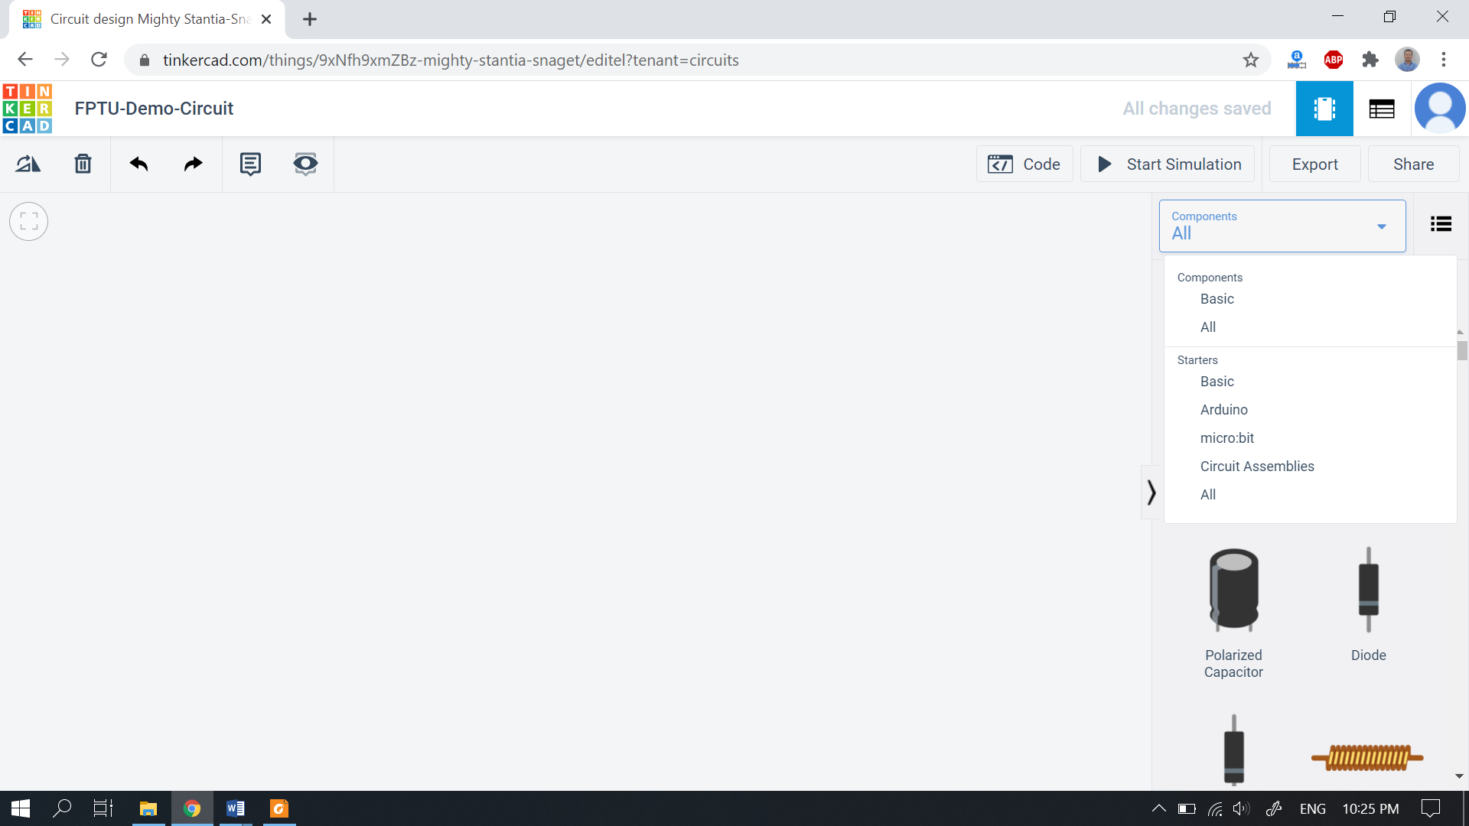

Tinkercad has many components and modules which can be used with Arduino UNO, some of the examples are shown in image below.

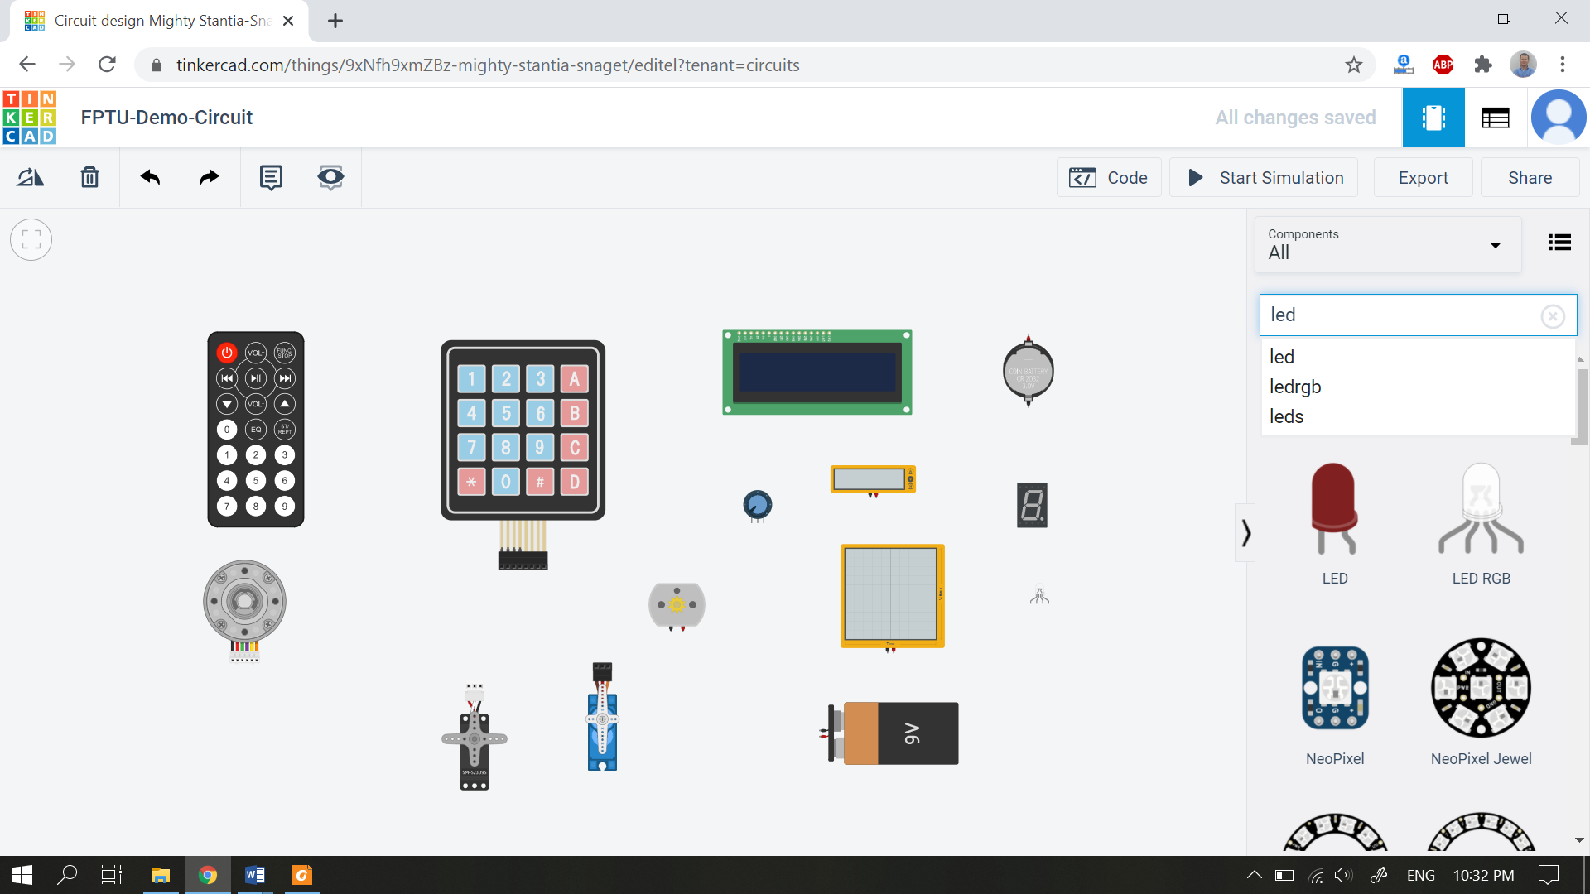

# IV. Building the Circuit

This tutorial will guide you by States of lights, used with sensor input (photoresistor).



Place all the components as image below by selecting them from the components section on right side. Click on the component to select and click again anywhere on workspace to place (You can search).

* Breadboard small
* Arduino Uno R3
* Resistor
* Photoresistor

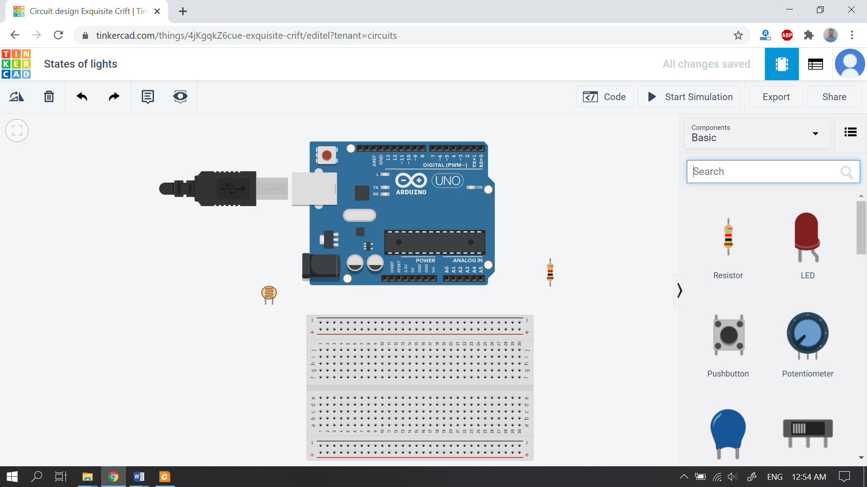

For changing the components value, select the component and change value.

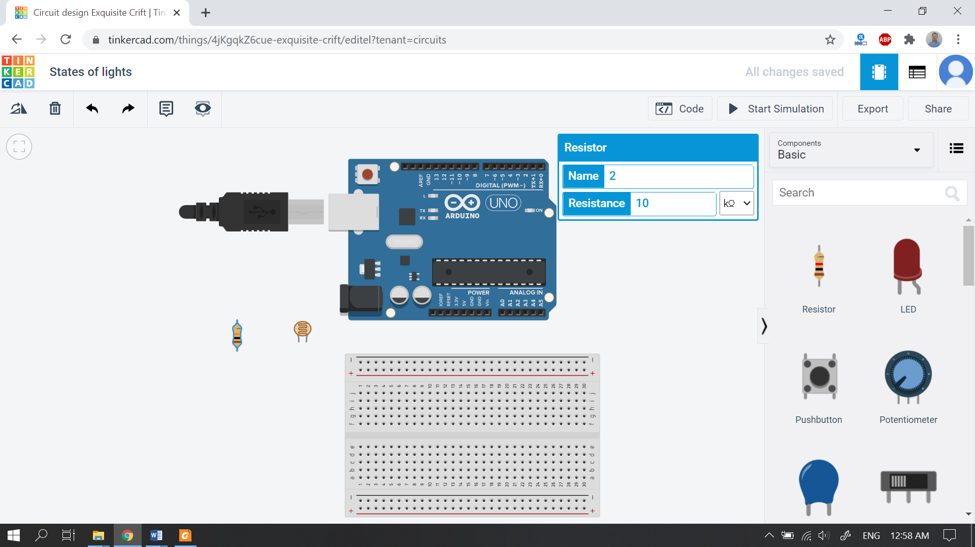

Move the components to righ position by drag and drop and rotating.

Hover over the points of the components to know the terminal name and click it to start wiring the components.

While wiring click **●** to bend the wire as show in image below.

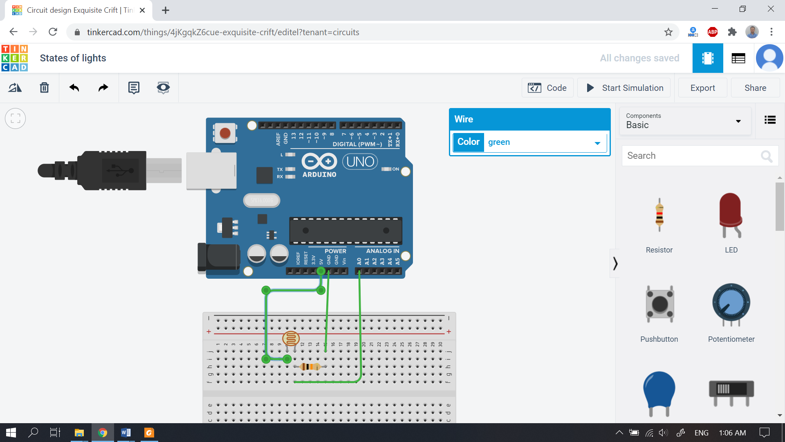

Click on wire to select the wire colour. This helps in differentiating between wire use. For example, 5v wire colour is Red and for GND (Ground) wire colour is Black.

Wire all the components as shown in the image below.

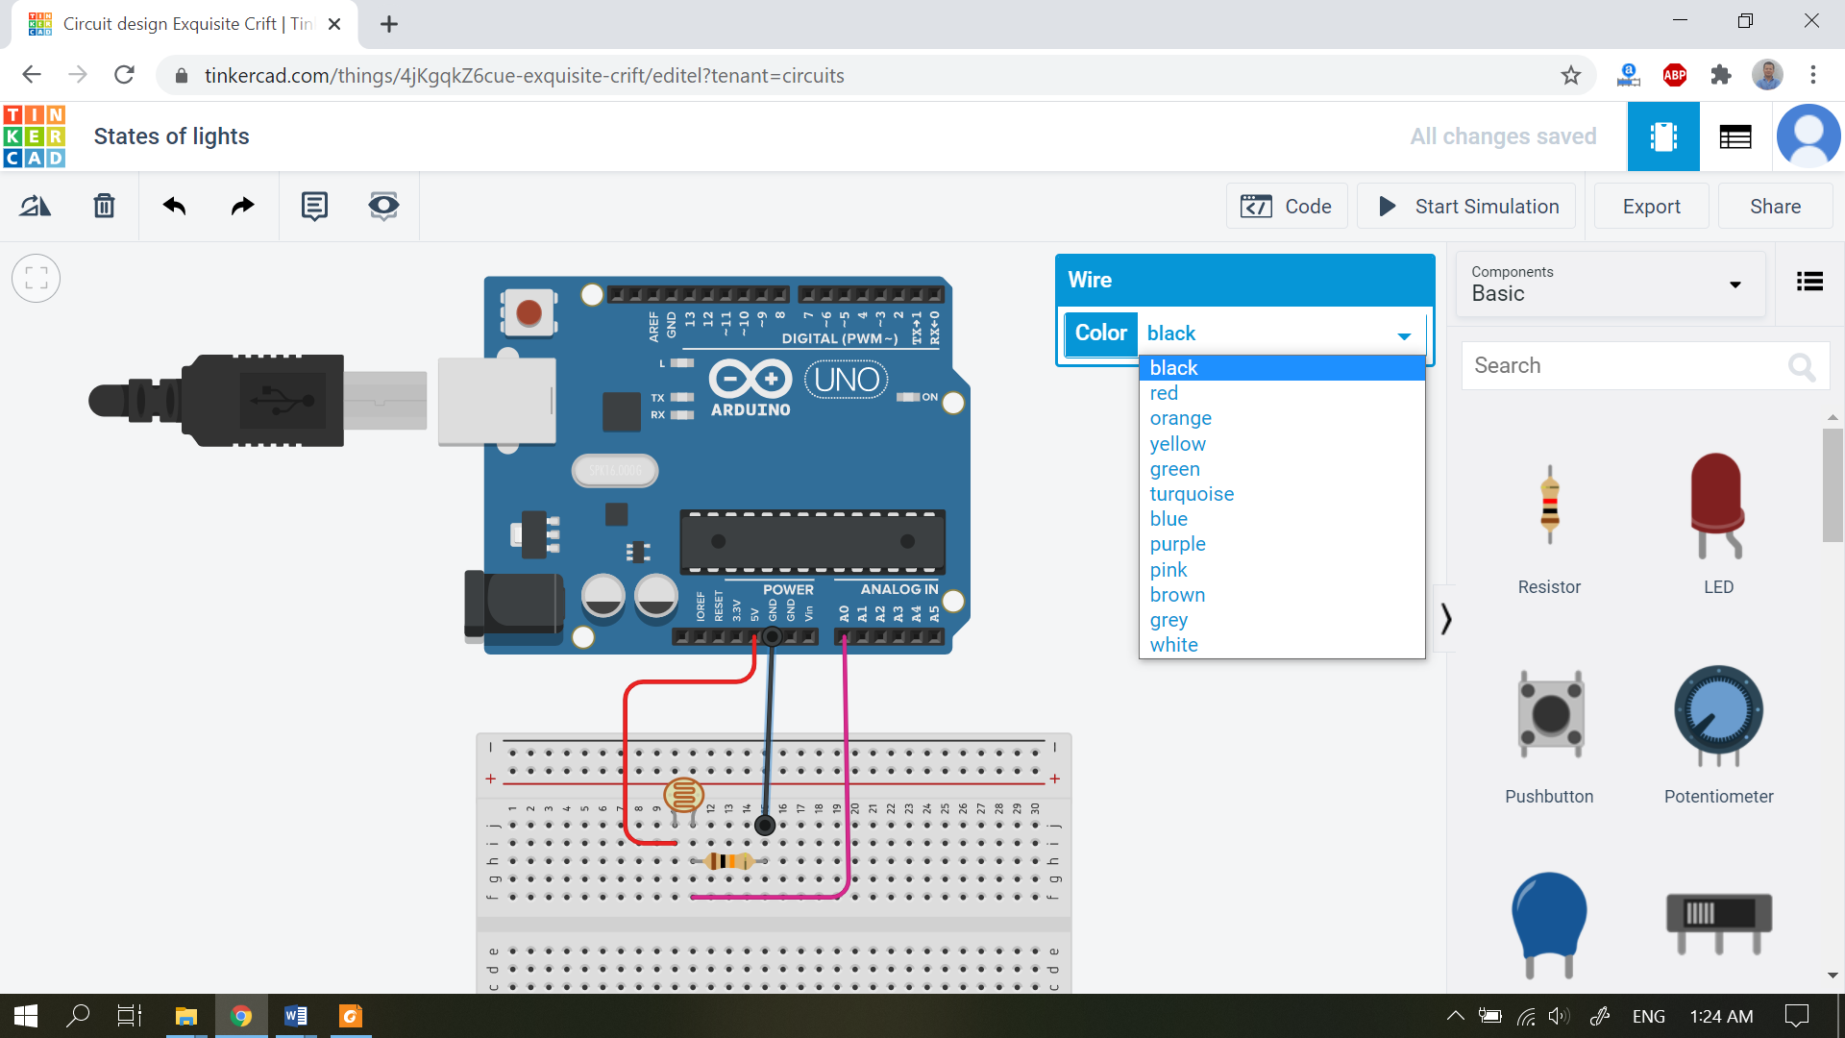

# V. Programming with Arduino

Once wiring is complete, select the **code** option to start coding.

Use the **Text** option to write the code for this tutorial or use block coding.

This is where all code can be written. Copy and paste the code shown on next page.

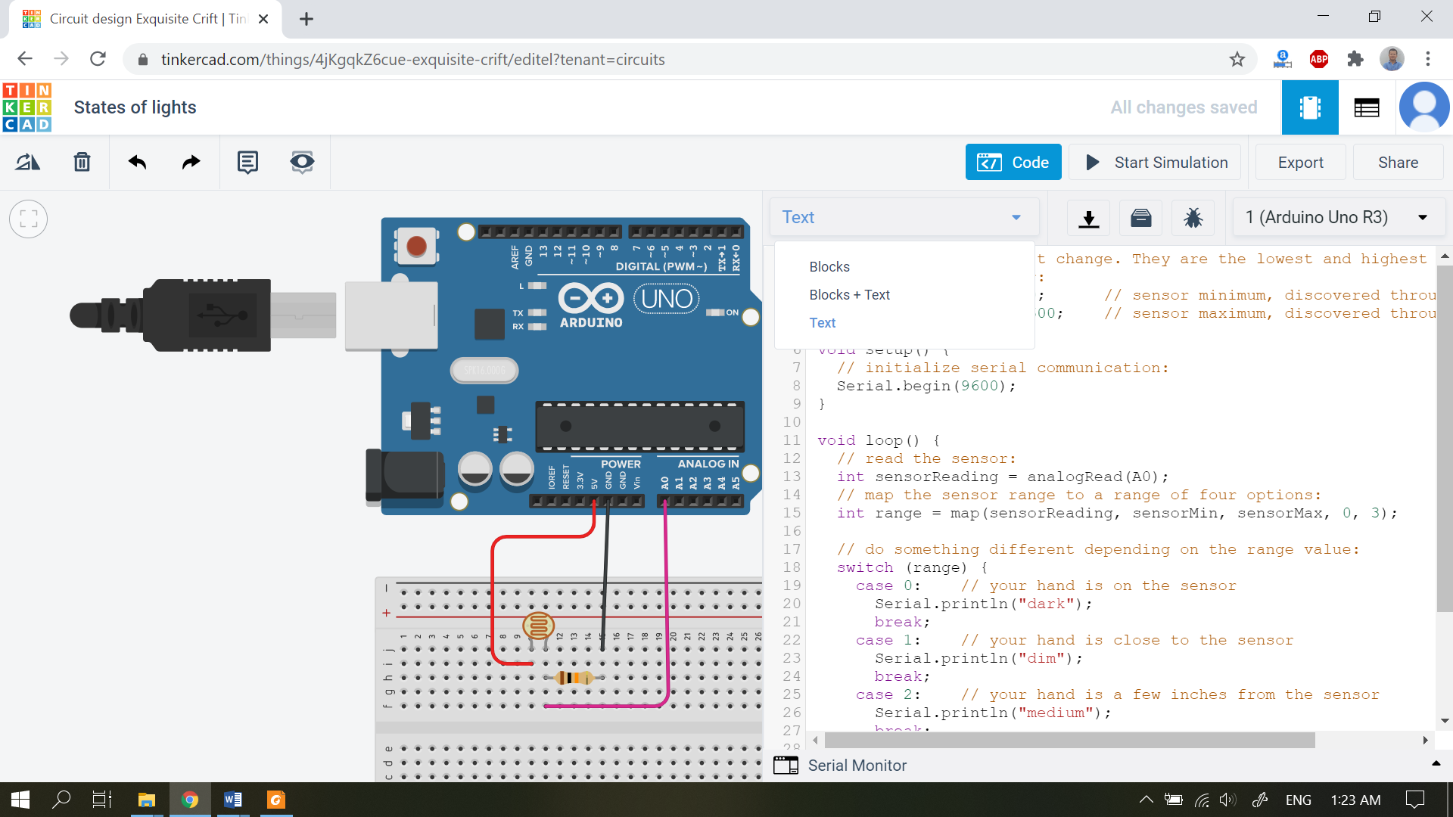

**Arduino Code**

*// these constants won't change. They are the lowest and highest readings you*  
*// get from your sensor:*  
const int sensorMin = 0;      *// sensor minimum, discovered through experiment*  
const int sensorMax = 600;    *// sensor maximum, discovered through experiment*  
  
void **setup**() {  
  *// initialize serial communication:*  
  Serial.begin(9600);  
}  
  
void **loop**() {  
  *// read the sensor:*  
  int sensorReading = analogRead(A0);

Serial.print(sensorReading);

  *// map the sensor range to a range of four options:*  
  int range = map(sensorReading, sensorMin, sensorMax, 0, 3);  
  
  *// do something different depending on the range value:*  
  switch (range) {  
    case 0:    *// your hand is on the sensor*  
      Serial.println(" - dark");  
      break;  
    case 1:    *// your hand is close to the sensor*  
      Serial.println(" - dim");  
      break;  
    case 2:    *// your hand is a few inches from the sensor*  
      Serial.println(" - medium");  
      break;  
    case 3:    *// your hand is nowhere near the sensor*  
      Serial.println(" - bright");  
      break;  
  }  
  delay(1);        *// delay in between reads for stability*  
}

**Start Simulation** after writing the code.

Click **Serial Monitor** to see the real time value of the LDR sensor output. This helps us know if its dark, dim, medium or bright.

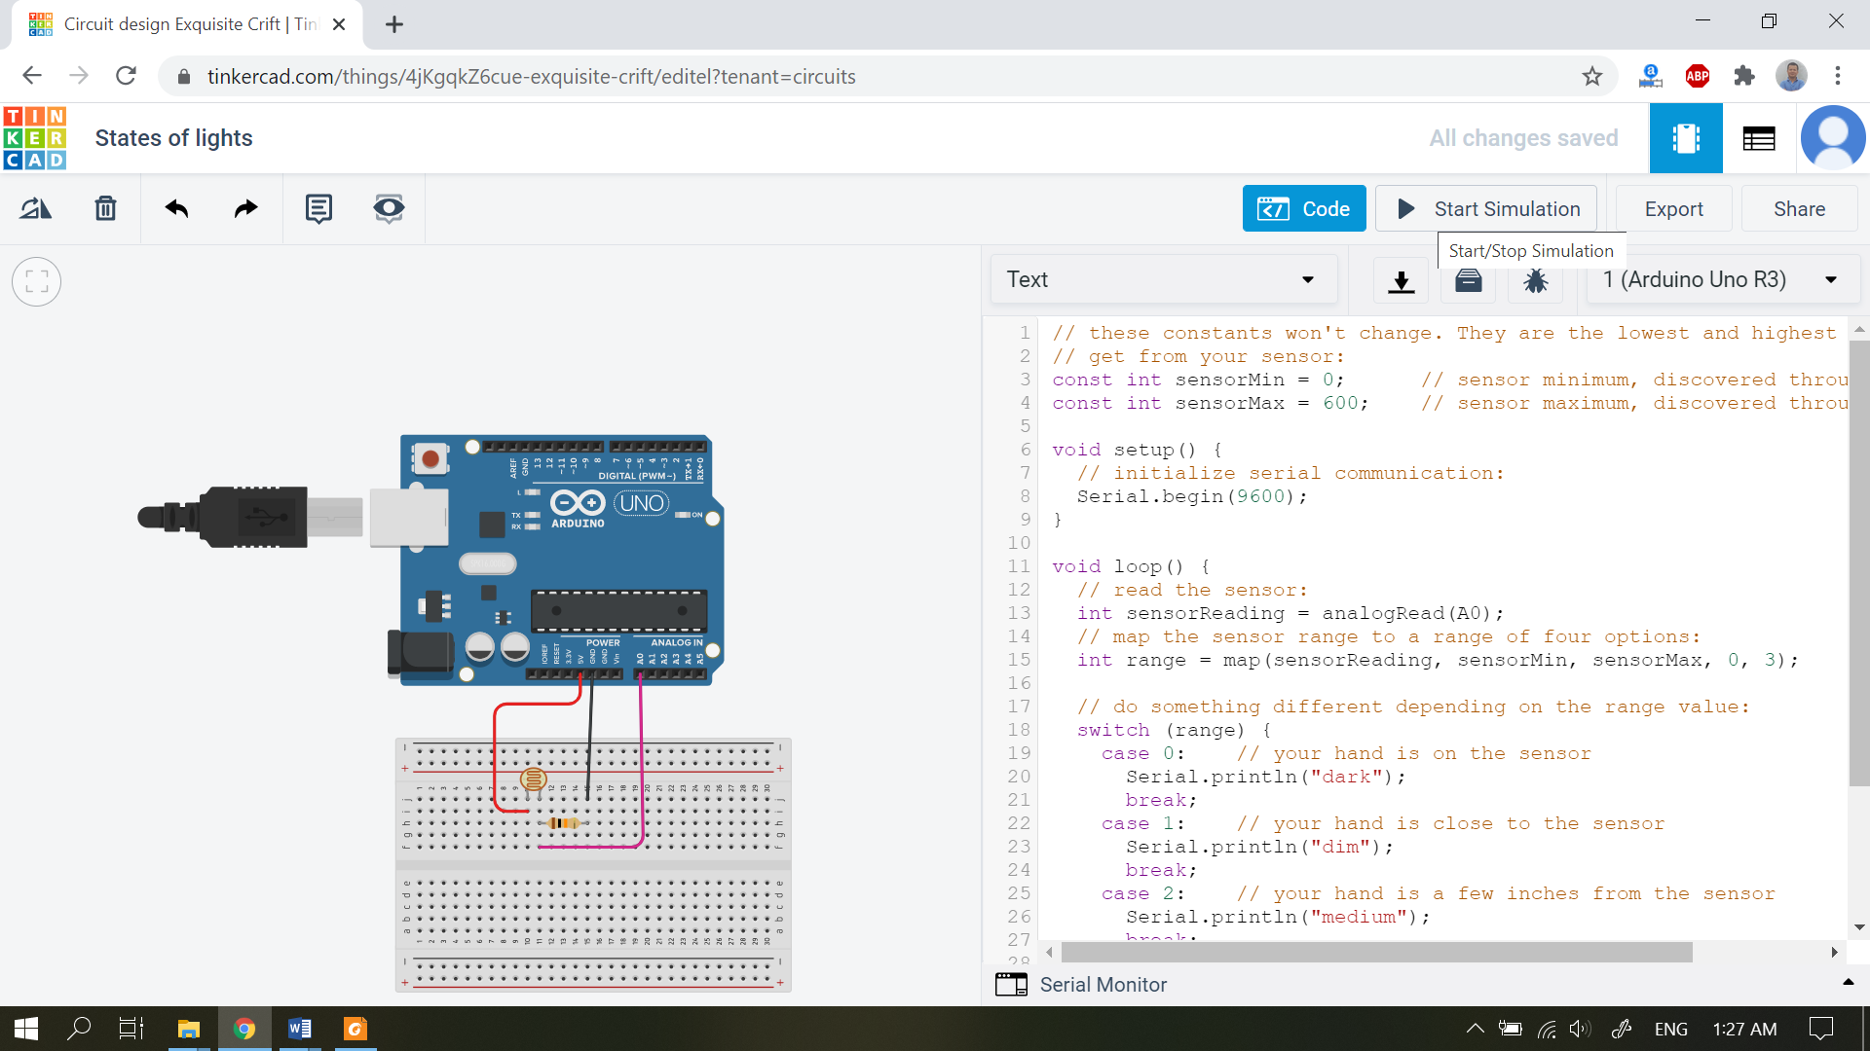

Slide the point on bar towards dark or bright, it detects the brightness intensity.

The raw values and the states can be seen on Serial Monitor.

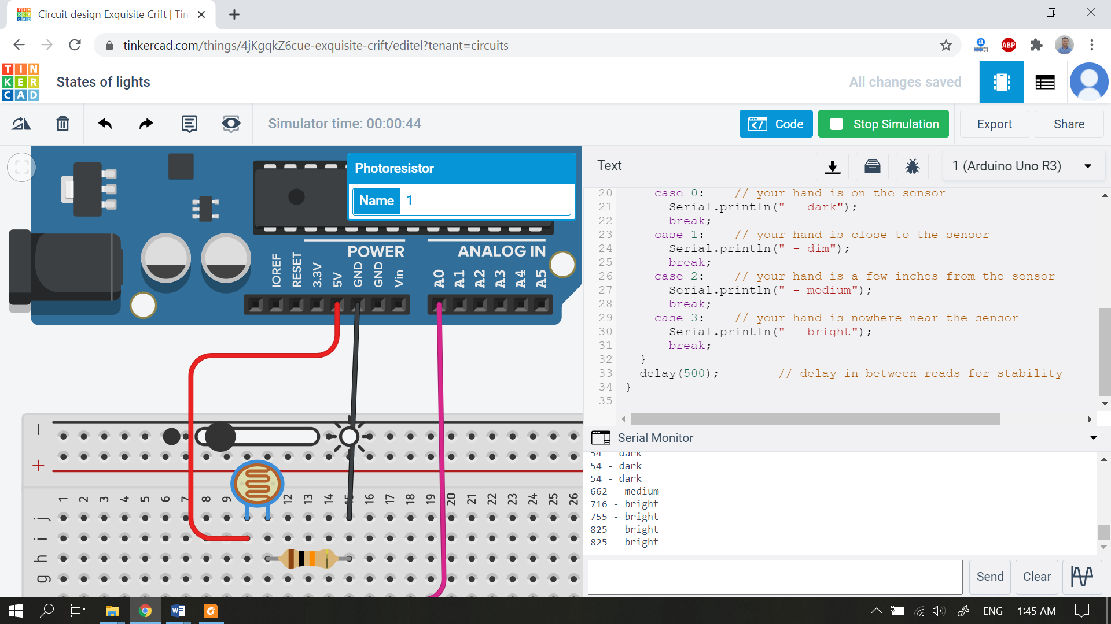

Dark Bright